Retail One training course

Bill of materials

Soluone

Retail One use two SAP bill of material, production and assembly.

For assembly bill of materials is automatically created, but for production is necessary execute the production.

We have two way for use bill of materials produce in SAP or in Retail One.

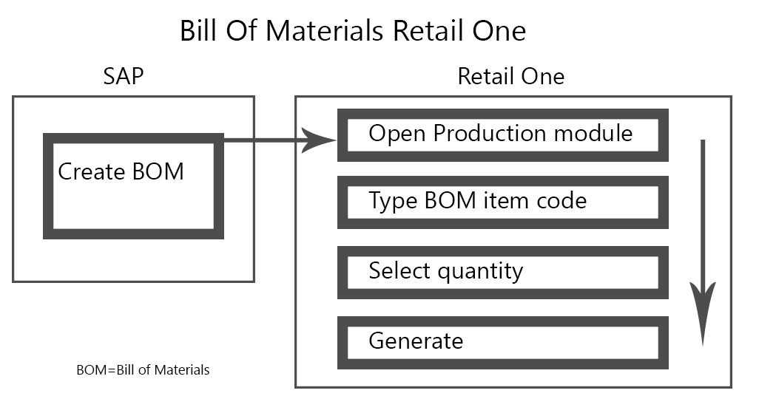

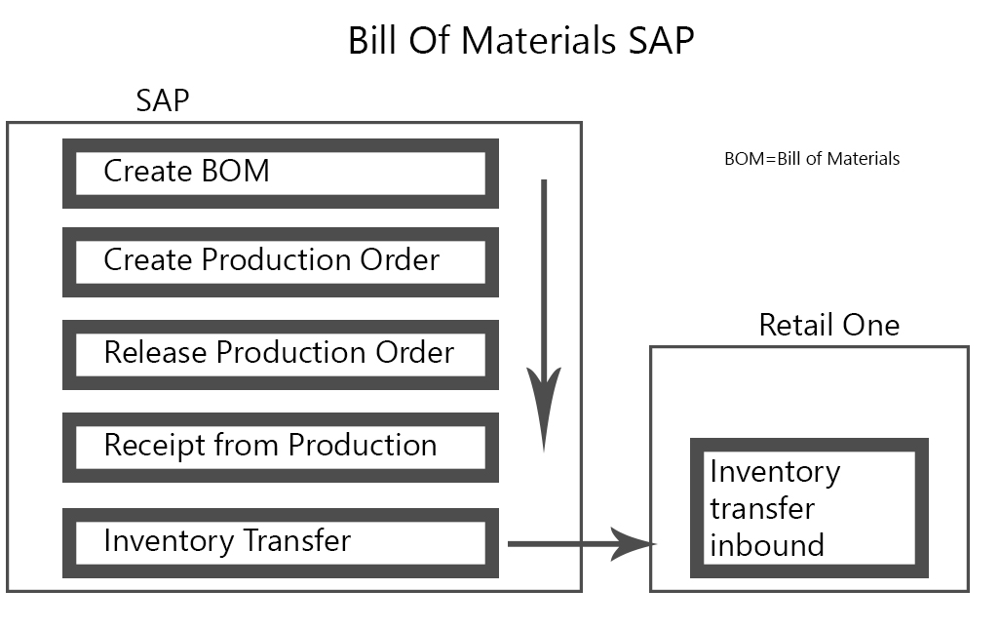

Bill of materials are created in SAP, Retail One read only the configuration.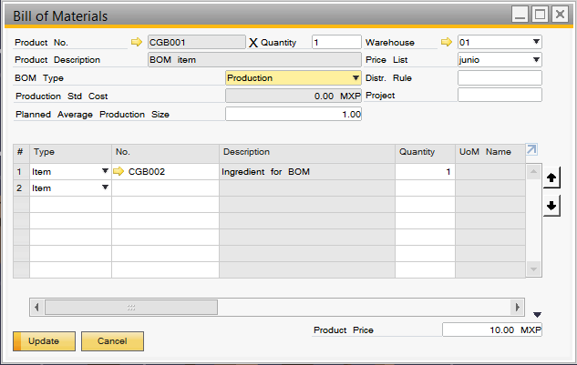

For do the production in Retail One, we access to Inventory>Production

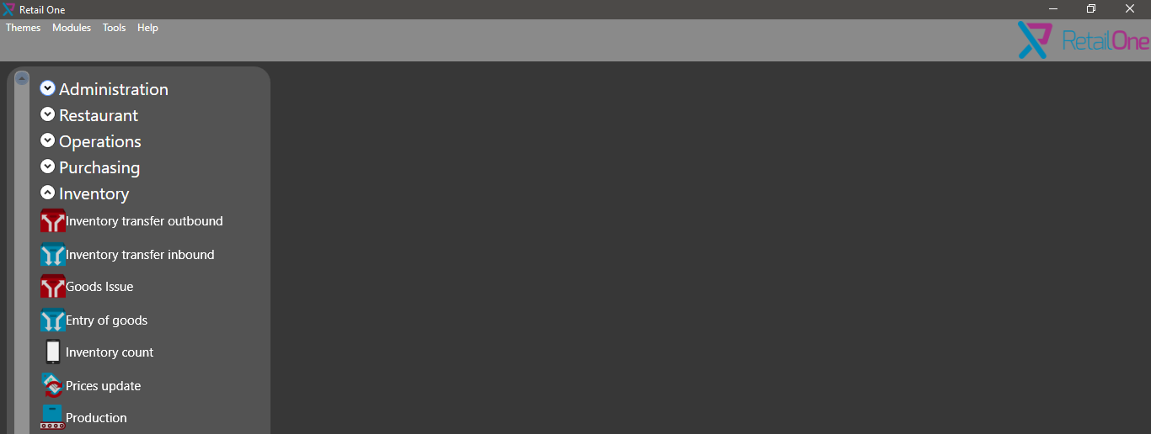

The first step is type the item code in text box.

Next select quantity to produce.

Also, we can change base quantity.

And click in Generate button.

